PROCESSOR PERFORMANCE ANALYSIS

by

Shivansh Singh 21BLC1010
Nikhil Chordia 21BLC1645
Sai Ayush Pattnaik 21BLC1297

Under the guidance of
Dr. Sindhuja. M


SCHOOL OF ELECTRONICS ENGINEERING
VELLORE INSTITUTE OF TECHNOLOGY, CHENNAI-600127

DECLARATION

I declare that this written submission represents my ideas in my own words and where others' ideas or words have been included, I have adequately cited and referenced the original sources. I also declare that I have adhered to all principles of academic honesty and integrity and have not misrepresented or fabricated or falsified any idea/data/fact/source in my submission. I understand that any violation of the above will be cause for disciplinary action by the Institute and can also evoke penal action from the sources which have thus not been properly cited or from whom proper permission has not been taken when needed.

Nikhil Chordia A | Shivansh Singh | Sai Ayush patnaik
21BLC1645 | 21BLC1010 | 21BLC1297
Date: | Date: | Date:

CERTIFICATE

It is certified that the work contained in the Continuous Assessment and Mini project(CAMP) titled “processor performance analysis,” by “Nikhil chordia a - 21BLC1645, Shivansh singh -21BLC1010 , Sai Ayush Patnaik - 21BLC1297” has been carried out under my supervision and that this work has not been submitted elsewhere for a degree

Signature of Supervisor
Name
School
VIT, Chennai
Month, Year

TABLE OF CONTENTS
Title |  | i
Declaration |  | ii
Certificate
Acknowledgements
List of Figures
List of Tables
List of Symbols and Abbreviations
Abstract
Table of Contents
Contents
1 | Introduction | 4
2 | Abstract | 5
3 | Data Collection Methods | 7
4 | Data Pre-Processing & Cleaning | 8
5 | Factors Affecting Processor Performance | 9
6 | Model Building & Selection | 10  10  11  12
   | 6.1 | Supervised Learning
   |  | 6.2 | Unsupervised Learning
   |  |  | 6.3 | Dimensionality reduction
7  8  9 | RStudio  Python (Google Colab)  Conclusions and Future Scope  References | 15  20
 | Appendix

Introduction
In the ever-evolving landscape of modern technology, processors stand as the heart and soul of computing devices, empowering us to achieve unparalleled feats of computation and data processing. As the demand for faster, more efficient computing continues to surge, delving into the intricate world of processor performance analysis becomes increasingly vital. Understanding how processors operate and identifying the factors that influence their efficiency is fundamental for optimizing system performance, shaping the future of technology, and enhancing the overall user experience.

The aim of this project is to embark on a comprehensive exploration of processor performance analysis, unearthing the complexities and mechanics that underpin these remarkable pieces of silicon wizardry. We will venture into the realm of microarchitecture, investigating the intricate design choices made by chip manufacturers to enhance processor speed, power efficiency, and overall performance. By examining a diverse array of processors, ranging from general-purpose CPUs to specialized GPUs and accelerators, we'll gain valuable insights into the diverse spectrum of computing devices that fuel our digital age.

Throughout this journey, we will utilize a range of analytical tools, benchmarking techniques, and performance metrics to measure and evaluate the efficiency of various processors under different workloads. By employing real-world use cases and performance-driven applications, we will bridge the gap between theoretical knowledge and practical implications, enabling us to make informed decisions about processor selection and optimization for specific tasks.

Moreover, this project will also explore the impact of emerging technologies, such as quantum computing and neuromorphic architectures, and their potential to revolutionize the landscape of processor performance in the not-so-distant future. By staying attuned to cutting-edge research and developments, we aim to envision the future trajectory

Abstract
In the fast-paced world of technology, processors serve as the central driving force behind computing devices, influencing their performance and overall efficiency. The quest for faster, more powerful processors continues to fuel the evolution of computing, making processor performance analysis an essential area of study. This project sets out to comprehensively explore the intricacies of processor performance, uncovering the underlying principles that govern their operation.

The project delves into microarchitecture, investigating the design choices made by chip manufacturers to optimize processor speed, power consumption, and overall effectiveness. A wide range of processors, from general-purpose CPUs to specialized GPUs and accelerators, are scrutinized to gain valuable insights into the diverse spectrum of computing devices that power our digital world.

To evaluate processor efficiency, various analytical tools, benchmarking techniques, and performance metrics are employed. Real-world use cases and performance-driven applications are utilized to bridge the gap between theory and practical implications, enabling informed decisions regarding processor selection and optimization for specific tasks.

Furthermore, the project explores the impact of emerging technologies, such as quantum computing and neuromorphic architectures, on the future of processor performance. Keeping abreast of cutting-edge research and developments helps envision the trajectory of processor technology and its broader implications in the field of computing.

By shedding light on the intricate workings of processors and their implications for computing efficiency, this project contributes to the ongoing pursuit of faster, more capable computing devices that drive innovation and reshape the technological landscape.

DATA COLLECTION METHODS

Hardware-Based Data Collection:
To understand processor performance better, we rely on hardware-based data collection. This approach uses special monitoring tools and performance counters built into the processor's hardware. These counters keep track of vital metrics like clock cycles, cache usage, instruction throughput, and memory access patterns. By directly tapping into the processor's internal mechanisms, we get real-time and detailed insights. This helps us identify bottlenecks, assess efficiency, and improve the design of modern processors.

CPU-Based Data Collection:
When we want to analyze the performance of a central processing unit (CPU), we use CPU-based data collection. We run benchmarking tests and performance checks on the CPU to measure its processing speed, power usage, and multi-core performance. Profiling tools help us understand how programs run, find hotspots, and spot areas where the CPU could be used more effectively. This analysis is vital for optimizing CPU designs for different tasks, making applications more responsive, and reducing energy consumption.

GPU-Based Data Collection:
To dig into the graphical processing unit (GPU) performance, we rely on GPU-based data collection. GPUs are crucial for tasks like gaming, scientific simulations, and machine learning. Using specialized profiling tools, we measure metrics like GPU utilization, memory bandwidth, and arithmetic throughput. This helps us find performance bottlenecks, understand parallel processing efficiency, and optimize algorithms. By doing this, we can design GPUs tailored to specific tasks and make the most of their incredible computing power.

DATA PRE-PROCESSING AND CLEANING

Handling Missing Values:
Missing values in datasets can occur due to various reasons, such as data entry errors or incomplete information. To handle missing values, we can either remove the rows or columns containing missing data or impute the missing values with appropriate estimates. Imputation methods can include using mean, median, mode, or more advanced techniques like regression-based imputation or k-nearest neighbors.

Outlier Detection:
Outliers are data points that deviate significantly from the majority of the data. Outliers can adversely affect the accuracy of statistical analyses and machine learning models. Detecting outliers involves using techniques like the z-score method, the modified z-score method, or visual methods like scatter plots or box plots. Once outliers are identified, we can choose to remove them, replace them with more reasonable values, or use robust statistical methods that are less sensitive to outliers.

Normalization and Scaling:
Normalization and scaling are methods used to bring different features or variables to a similar scale, ensuring that no single feature dominates the analysis or model training. Common normalization techniques include min-max scaling, which scales the data to a specific range (e.g., 0 to 1), and z-score normalization, which transforms data to have a mean of 0 and a standard deviation of 1. Scaling ensures that all features contribute equally to the analysis and prevents issues caused by different units or scales.

FACTORS AFFECTING PROCESSOR PERFORMANCE

Clock Speed: The clock speed of a processor represents the rate at which it executes instructions. Measured in gigahertz (GHz), a higher clock speed generally translates to faster processing, as the CPU can handle more instructions within a given time frame. However, comparing clock speeds alone might not always provide a complete picture of performance, as other factors like the processor's architecture and the number of cores also come into play.
Number of Cores: Modern processors often have multiple cores, enabling them to perform multiple tasks simultaneously. Each core functions independently, allowing for parallel processing. This feature is especially advantageous for tasks that can be split into smaller, independent parts, such as video rendering or data analysis. More cores usually result in better multitasking performance and improved efficiency for workloads that can take advantage of parallel processing.
Cache Size: The processor cache is a small, high-speed memory located directly on the CPU. Its purpose is to store frequently accessed data and instructions, reducing the time spent waiting for data from slower memory sources like RAM. A larger cache can significantly improve performance, as the processor can quickly access the most critical data, resulting in reduced latency and faster execution of instructions.
Thermal Design Power (TDP): TDP represents the maximum amount of heat a processor generates under heavy workload. It is measured in watts and provides critical information about the chip's power requirements and heat dissipation capabilities. A lower TDP is desirable for various reasons: it indicates higher energy efficiency, reduces power consumption, and results in less heat being produced during the processor's operation. This aspect is particularly crucial in mobile devices and data centers where power consumption and cooling requirements are vital considerations.

MODEL BUILDING AND SELECTION
Supervised Learning:

Supervised learning is a type of machine learning where the model is trained on labeled data, meaning that both input features and corresponding output labels are provided. The process of building and selecting a supervised learning model typically involves the following steps:
Data Preprocessing: This includes data cleaning, handling missing values, and feature engineering to ensure the data is suitable for training the model.

Feature Selection: Identifying the most relevant features from the dataset to use as inputs for the model. This step is essential for improving model performance and reducing overfitting.

Model Selection: Choosing the appropriate supervised learning algorithm that matches the nature of the problem and the data. Common algorithms include Linear Regression, Decision Trees, Random Forests, Support Vector Machines (SVM), and Neural Networks.

Model Training: Using the labeled data to train the chosen model. During training, the model learns to map the input features to the corresponding output labels.

Model Evaluation: Assessing the performance of the trained model using metrics such as accuracy, precision, recall, F1-score, or mean squared error (MSE), depending on the nature of the problem (classification or regression).

Hyperparameter Tuning: Fine-tuning the model's hyperparameters to optimize its performance further. Techniques like cross-validation are often used to avoid overfitting.

Unsupervised Learning:
In contrast to supervised learning, unsupervised learning involves working with unlabeled data, where the model must identify patterns and relationships within the data without explicit guidance. The model building and selection process for unsupervised learning includes the following steps:
Data Preprocessing: Similar to supervised learning, data preprocessing is essential to clean and prepare the data for analysis.

Dimensionality Reduction: When dealing with high-dimensional data, dimensionality reduction techniques like Principal Component Analysis (PCA) or t-distributed Stochastic Neighbor Embedding (t-SNE) are employed to reduce the number of features and visualize complex data in lower dimensions.

Clustering: Applying clustering algorithms, such as K-Means, Hierarchical Clustering, or Density-Based Spatial Clustering of Applications with Noise (DBSCAN), to group similar data points together based on their features.

Model Evaluation: In unsupervised learning, model evaluation is often more challenging since there are no explicit labels for comparison. Instead, evaluation can involve visual inspection and domain knowledge to assess the quality and interpretability of the clustering results.

Interpretation: Understanding the clusters and patterns discovered by the model is crucial for extracting meaningful insights and informing decision-making.

Dimensionality reduction :
Dimensionality reduction is a critical technique in machine learning and data analysis that involves reducing the number of input features or variables in a dataset while preserving its important information. Here are some key points on dimensionality reduction:

Curse of Dimensionality: High-dimensional datasets can suffer from the curse of dimensionality, where the data becomes sparse, making it difficult to find meaningful patterns or relationships. Dimensionality reduction helps mitigate this problem by reducing the number of features and focusing on the most relevant ones.

Feature Selection vs. Feature Extraction: Dimensionality reduction techniques can be categorized into feature selection and feature extraction methods. Feature selection chooses a subset of the original features, while feature extraction creates new, lower-dimensional features that capture the essence of the data.

Principal Component Analysis (PCA): PCA is one of the most commonly used dimensionality reduction techniques. It transforms the original features into a new set of orthogonal features called principal components. These components are ranked by the amount of variance they explain in the data, and we can choose to keep the top N components to achieve dimensionality reduction.

Singular Value Decomposition (SVD): SVD is a linear algebra technique used in various dimensionality reduction methods. It decomposes the data matrix into three matrices, and the middle matrix contains the singular values that can be used to create reduced feature representations.

t-distributed Stochastic Neighbor Embedding (t-SNE): t-SNE is a popular nonlinear dimensionality reduction method used for data visualization. It aims to preserve the pairwise similarity between data points in a lower-dimensional space, making it useful for visualizing complex datasets in 2D or 3D.

Linear Discriminant Analysis (LDA): LDA is a dimensionality reduction technique that is particularly useful for supervised classification problems. It aims to maximize the separation between different classes while minimizing the variance within each class.

Overfitting Reduction: Dimensionality reduction can help prevent overfitting in machine learning models. By reducing the number of features, we reduce the risk of the model fitting noise or irrelevant information in the data.

Interpretability and Visualization: Dimensionality reduction can aid in understanding complex datasets by visualizing them in a lower-dimensional space. This enables easier interpretation and communication of insights to stakeholders.

Loss of Information: Dimensionality reduction may lead to some loss of information, as the reduced features might not capture all the details present in the original data. The balance between dimensionality reduction and information retention is a crucial consideration.

Application Areas: Dimensionality reduction finds applications in various fields such as image processing, natural language processing, recommendation systems, and bioinformatics, where high-dimensional datasets are common.

EVALUATION OF CACHE PERFORMANCE
Evaluating cache performance is crucial in computer systems to understand how effectively the cache is serving its purpose of speeding up data access and reducing memory access latency. Two important metrics used to assess cache performance are cache hit ratio and cache miss penalty.

Cache Hit Ratio:
Cache hit ratio, also known as cache hit rate or cache hit percentage, measures the percentage of memory accesses that are successfully served by the cache. It is calculated as the ratio of cache hits to the total number of memory accesses:
Cache Hit Ratio = (Number of Cache Hits) / (Total Number of Memory Accesses)

A high cache hit ratio indicates that a significant portion of memory accesses is being served from the cache, resulting in improved performance. Conversely, a low cache hit ratio suggests that the cache is not effectively retaining frequently accessed data, leading to more cache misses and potential performance degradation.

Cache Miss Penalty:
Cache miss penalty is the additional time required to fetch data from the main memory when a cache miss occurs. When a memory access results in a cache miss, the processor needs to retrieve the required data from the slower main memory, incurring a penalty in terms of access time. This additional time is known as the cache miss penalty.
Reducing the cache miss penalty is crucial for improving cache performance. Techniques like prefetching, where data is fetched from main memory in advance, or using larger cache sizes can help mitigate the impact of cache misses.

\
RStudio:
Code:
library(readxl)
library(ggplot2)
# Read the CSV file
data <- read.csv("/Users/Pravin/Desktop/CPU_benchmark_v4.csv")
# Select the columns of interest
columns_of_interest <- c("cpuMark", "cpuValue", "threadMark")
# Convert columns of interest to numeric
data[columns_of_interest] <- lapply(data[columns_of_interest], function(x) as.numeric(as.character(x)))
# Calculate correlation with Perf column, ignoring 0 and NA values
correlation_values <- sapply(data[columns_of_interest], function(column) {
numeric_values <- !is.na(column) & column != 0
cor(column[numeric_values], data$Perf[numeric_values])
})
# Create a data frame with column names and correlation values
correlation_data <- data.frame(Column = columns_of_interest, Correlation = correlation_values)
# Print the correlation values with a line and plot for each column
for (i in seq_along(columns_of_interest)) {
# Print the correlation value with a line
cat(sprintf("Correlation between %s and Perf: %.3f\n", correlation_data$Column[i], correlation_data$Correlation[i]))
cat(paste(rep("-", 50), collapse = ""), "\n")
# Create a line plot for the specific column
correlation_plot <- ggplot(correlation_data, aes(x = Column, y = Correlation, group = 1)) +
geom_line(color = "steelblue") +
geom_point(color = "steelblue", size = 3) +
labs(x = "Column", y = "Correlation") +
ggtitle(paste("Correlation between", correlation_data$Column[i], "and Perf")) +
theme_minimal()
# Save the correlation plot as a separate file
file_name <- paste0("correlation_plot_", columns_of_interest[i], ".png")
ggsave(file_name, correlation_plot, width = 6, height = 4, dpi = 300)
}
# Calculate correlation between cpuMark and Perf
correlation_cpuMark_Perf <- cor(data$cpuMark, data$Perf)
# Print the correlation value
correlation_label <- sprintf("Correlation: %.3f", correlation_cpuMark_Perf)
# Create a scatter plot of cpuMark against Perf with correlation line
cpuMark_Perf_plot <- ggplot(data, aes(x = cpuMark, y = Perf)) +
geom_point(color = "steelblue", size = 3) +
geom_smooth(method = "lm", se = FALSE, color = "red") +
labs(x = "cpuMark", y = "Perf") +
ggtitle("Correlation between cpuMark and Perf") +
theme_minimal() +
geom_text(x = max(data$cpuMark), y = max(data$Perf), label = correlation_label, hjust = 1, vjust = 1)
# Display the scatter plot
print(cpuMark_Perf_plot)
# Calculate correlation between cpuValue and Perf
correlation_cpuValue_Perf <- cor(data$cpuValue, data$Perf)
# Print the correlation value
correlation_label <- sprintf("Correlation: %.3f", correlation_cpuValue_Perf)
# Create a scatter plot of cpuValue against Perf with correlation line
cpuValue_Perf_plot <- ggplot(data, aes(x = cpuValue, y = Perf)) +
geom_point(color = "steelblue", size = 3) +
geom_smooth(method = "lm", se = FALSE, color = "red") +
labs(x = "cpuValue", y = "Perf") +
ggtitle("Correlation between cpuValue and Perf") +
theme_minimal() +
geom_text(x = max(data$cpuValue), y = max(data$Perf), label = correlation_label, hjust = 1, vjust = 1)
# Display the scatter plot
print(cpuValue_Perf_plot)
# Calculate correlation between threadMark and Perf
correlation_threadMark_Perf <- cor(data$threadMark, data$Perf)
# Print the correlation value
correlation_label <- sprintf("Correlation: %.3f", correlation_threadMark_Perf)
# Create a scatter plot of threadMark against Perf with correlation line
threadMark_Perf_plot <- ggplot(data, aes(x = threadMark, y = Perf)) +
geom_point(color = "steelblue", size = 3) +
geom_smooth(method = "lm", se = FALSE, color = "red") +
labs(x = "threadMark", y = "Perf") +
ggtitle("Correlation between threadMark and Perf") +
theme_minimal() +
geom_text(x = max(data$threadMark), y = max(data$Perf), label = correlation_label, hjust = 1, vjust = 1)
# Display the scatter plot
print(threadMark_Perf_plot)

Outputs:
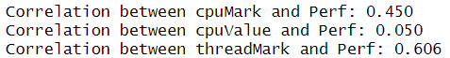
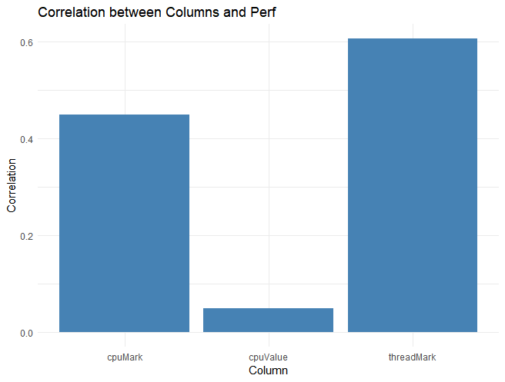
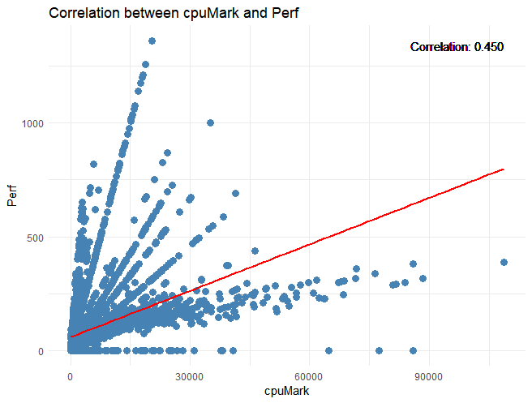
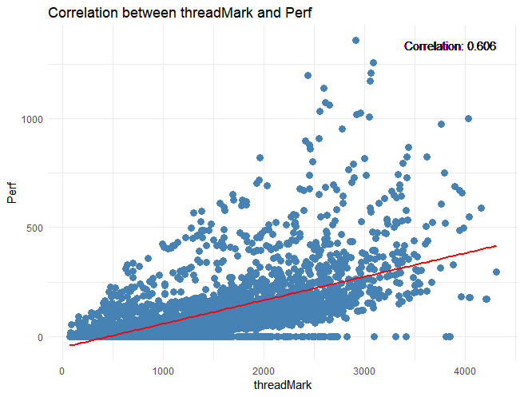
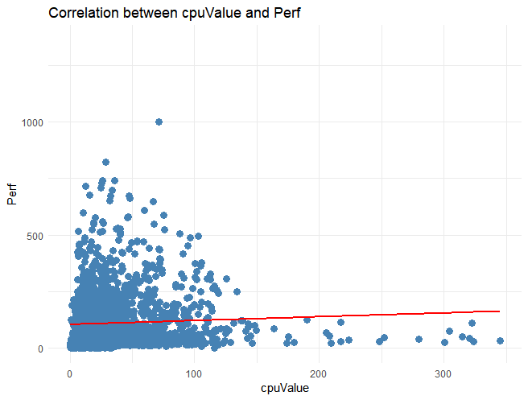
Over here we can see that not all data from our data set forms corellation with our perfromance value however we can use the metrics such as cpuMark and threadMark to make our machine learning model.
Python code:
1)Importing csv file
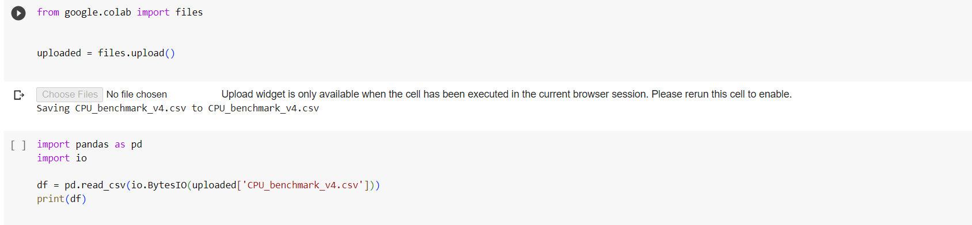

Dataset:
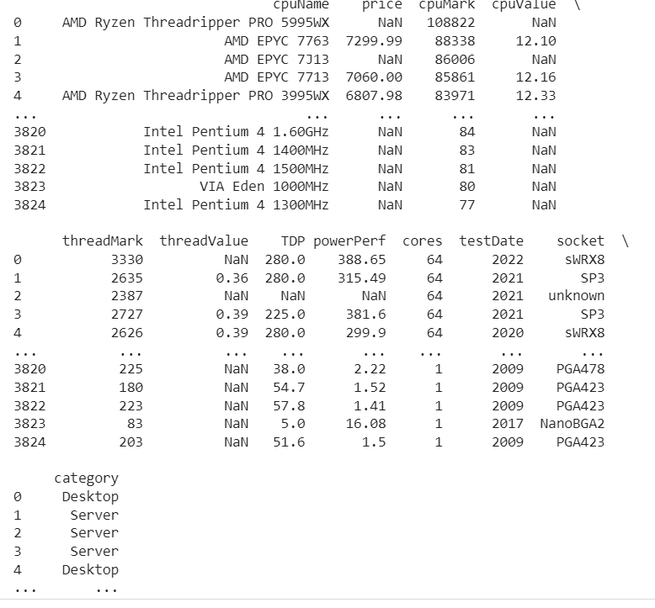
2) Plotting the specs with respect to each other to graphically represent the relation
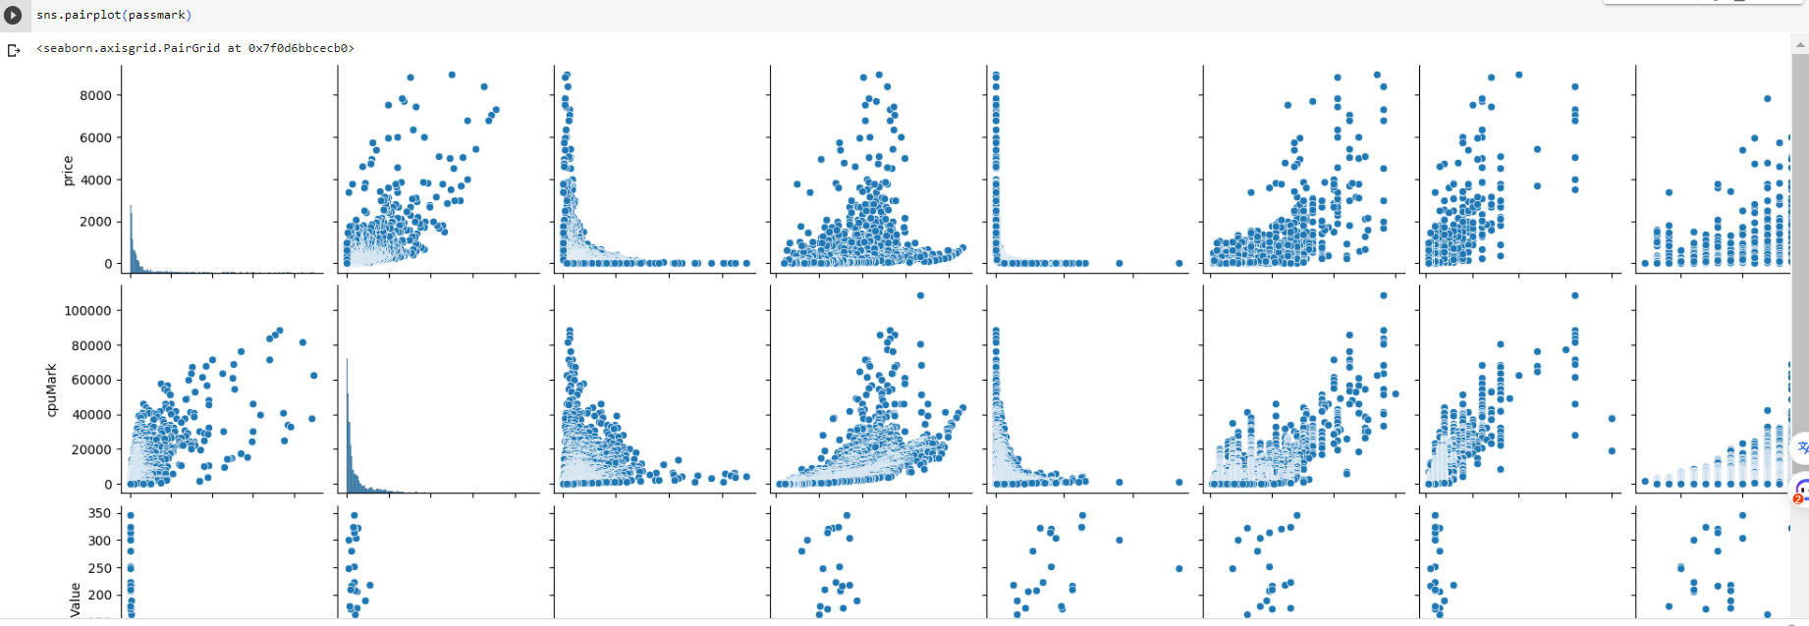
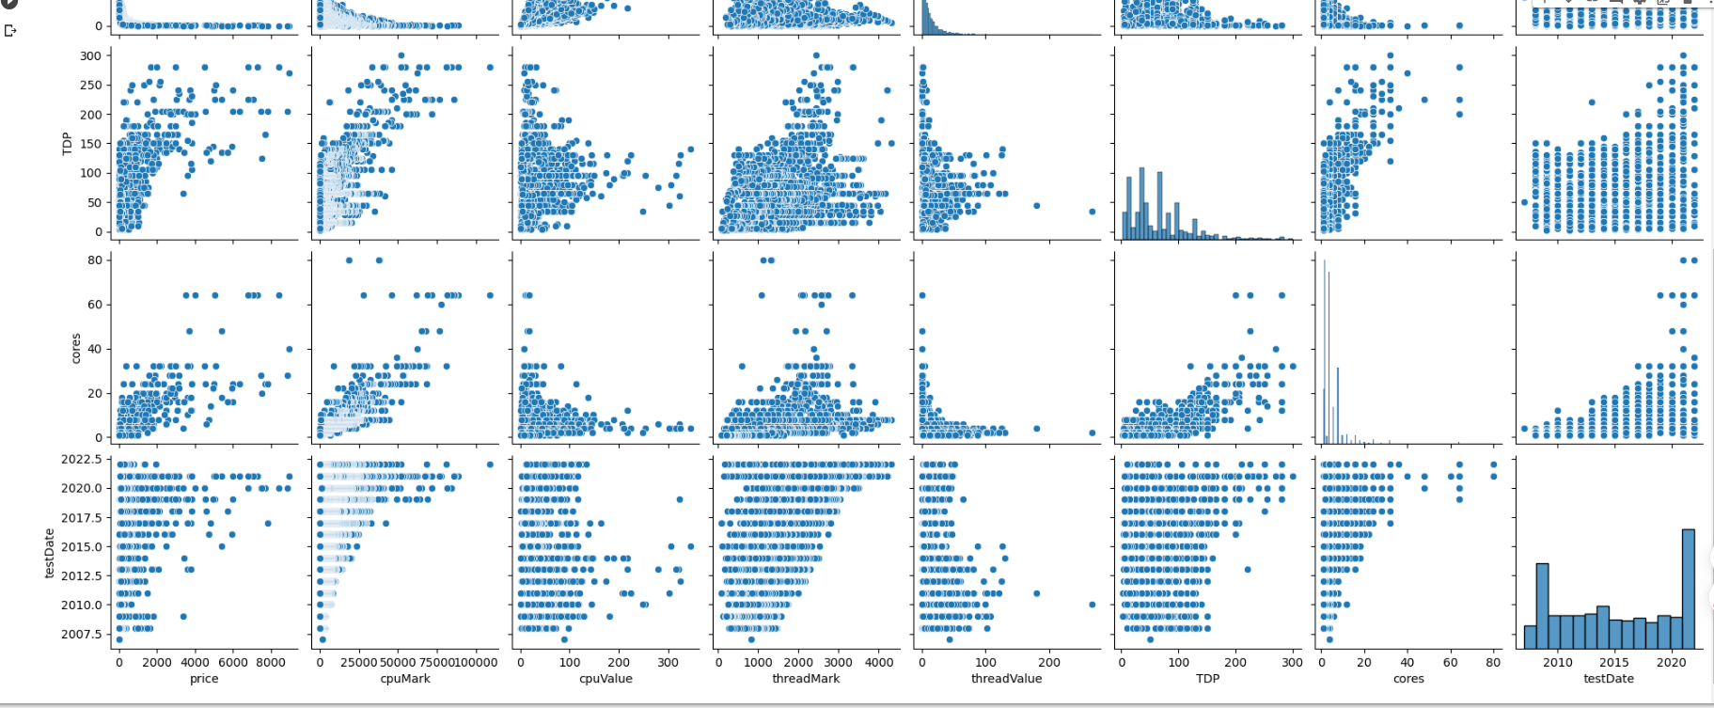

3) Showing the market share of pc’s and laptops and for which processor performance matters more.
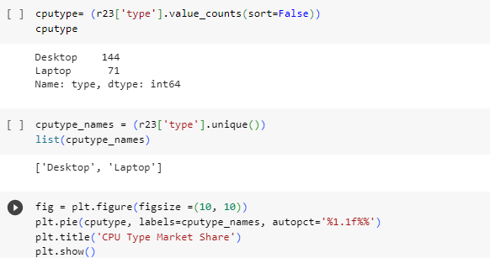
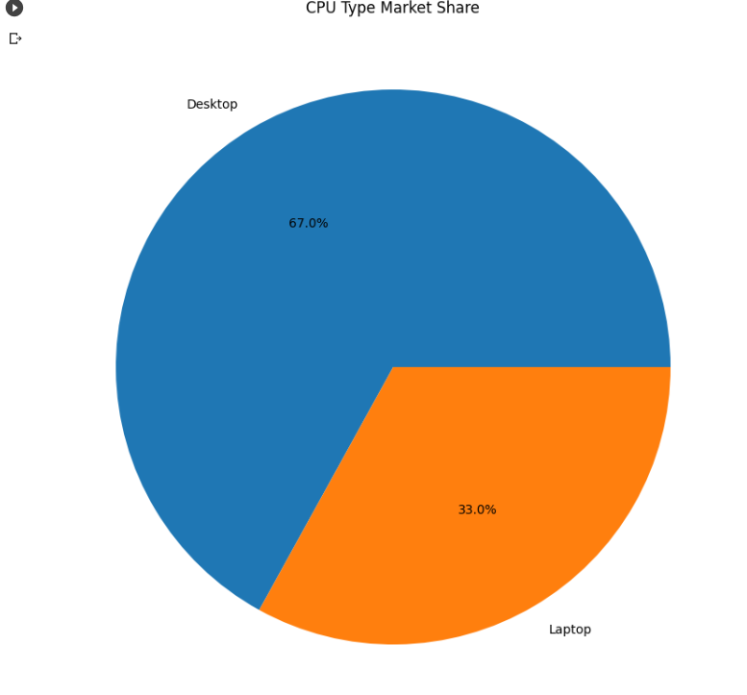
4) importing linear regression model and printing the single speed and turbo clock. Single speed is the factor on which the performance does not depend much so we can remove it.
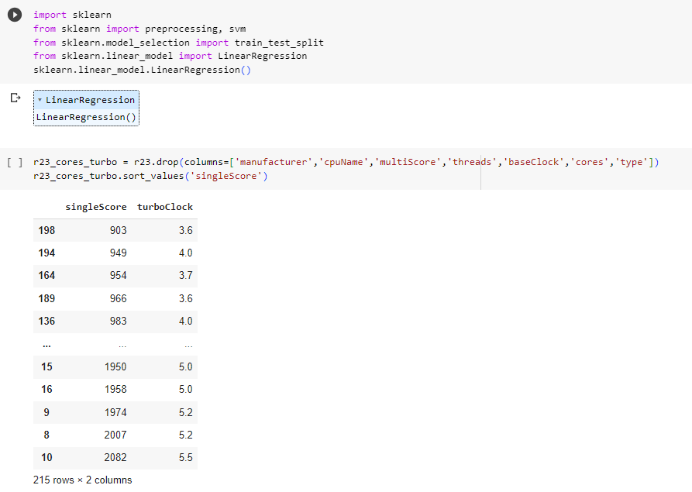

5) Plotting the graph between them
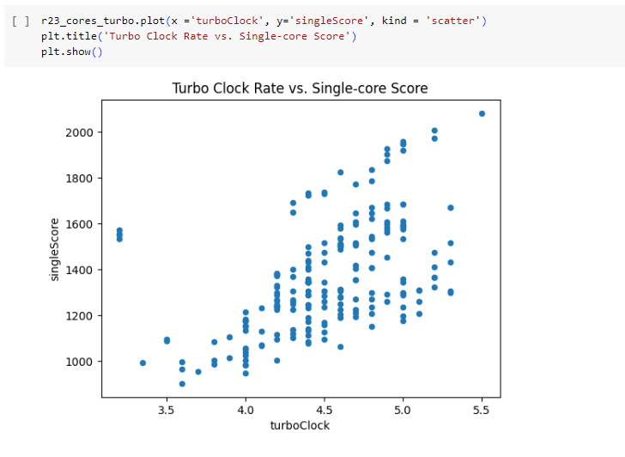
6) Using logistic relation where we map the factors to the class field which is the performance factor of the processor.
Logistic regression: This type of statistical model (also known as logit model) is often used for classification and predictive analytics. Logistic regression estimates the probability of an event occurring, such as voted or didn’t vote, based on a given dataset of independent variables. Since the outcome is a probability, the dependent variable is bounded between 0 and 1.
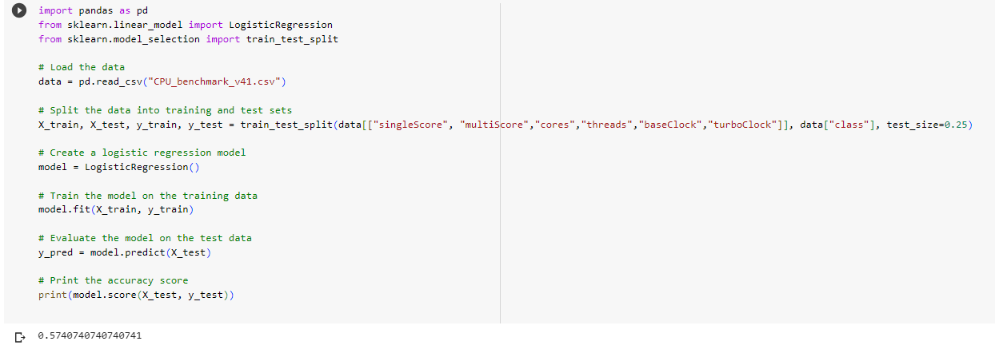
7) Using Histgradientboost classifier model to train the ml program
This estimator is much faster than GradientBoostingClassifier for big datasets (n_samples >= 10 000).This estimator has native support for missing values (NaNs). During training, the tree grower learns at each split point whether samples with missing values should go to the left or right child, based on the potential gain. When predicting, samples with missing values are assigned to the left or right child consequently. If no missing values were encountered for a given feature during training, then samples with missing values are mapped to whichever child has the most samples.
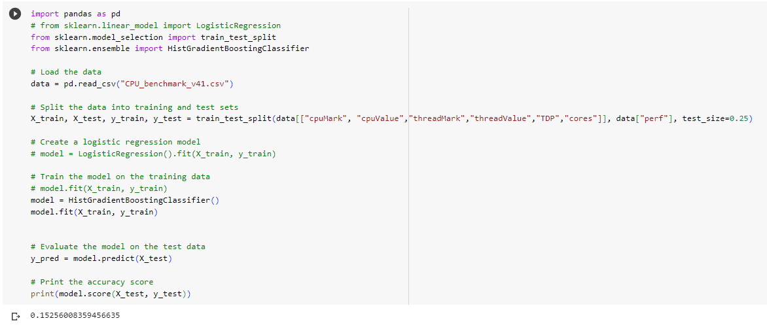
8) Relation between no of cores and multicore score
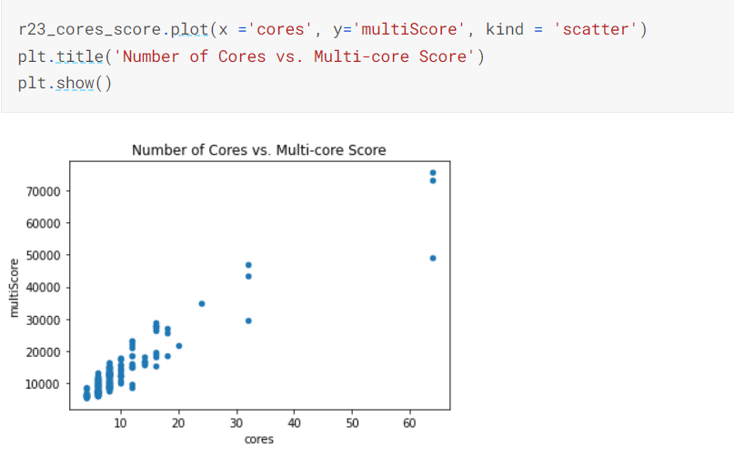
9) Various cpu’s available with their socket type